

Practical Exam
Web Development
Case study
Medical Equipment Supply Management System
NAME | ID | MAJOR
Bahaa Yassin shams | 202204811 | NT
Ziad fathy kasem | 202202017 | NT
Seif eldin Ayman | 202203572 | NT
Faris mahmoudd salah | 202203798 | CS
Seif omar el sayed | 202204510 | CS
Shehad Khaled omar | 202205097 | CS

Supervised by : Dr.Nagwa Yaseen
Eng.Mahmoud hammad
Eng.Nada Hamdy

Medical Equipment Supply Management System

Introduction:
Project Overview
The Medical Equipment Supply Management System is an enterprise solution designed to make the complex operations of a fastly growing medical supply company. Currently operating across multiple cities with a diverse client base including major hospitals and private clinics the organization faces significant operational challenges due to a reliance on manual processes.
As the company scales, the lack of a unified system has led to critical inefficiencies: doubleselling of limited inventory, delayed financial reporting, and a lack of real-time visibility across warehouse locations. The project aims to replace these old methods with a centralized, A central online system that connects stock, sales, and money in one place.
1) Requirements Analysis (SRS)
1. Stakeholders Identification
Stakeholder | Why They Were Chosen
Managers / Board | They fund the system, define strategic goals, and are concerned about scalability after signing with big hospitals.
Warehouse Operator | Directly responsible for inventory accuracy and daily stock checks; currently suffer from duplicated sales and manual tracking.
Sales Representatives | Use inventory data to sell products; currently selling the same stock multiple times due to lack of real-time updates.
Accountants / Finance Team | Spend days reconciling Excel sheets and disconnected billing software; need automation and accuracy.
IT / System Administrator | Responsible for system availability, security, maintenance, and integration across branches and warehouses.

A. Functional Requirements (FR)
- Centralized Inventory Management
The system shall maintain a real-time centralized inventory across all warehouses.
- Sales Order Processing
The system shall validate stock availability before confirming any sales order.
- Automated Billing & Invoicing
The system shall automatically generate invoices linked to sales orders.
- Warehouse Operations Management
The system shall support stock receiving, transfers, adjustments, and dispatch tracking.
- Multi-Branch Sales Management
The system shall allow sales branches to place orders based on allocated inventory.
- Reporting & Analytics
The system shall generate daily, weekly, and monthly reports for inventory, sales, and financials.
- Customer Management
The system shall store customer profiles, contracts, pricing, and order history.

B. Non-Functional Requirements (NFR)
- Scalability
The system must handle at least 3× current workload growth without performance degradation.
- Availability
The system shall have 99.5% uptime, especially during business hours.
- Data Consistency & Integrity less than 24Hrs
Inventory data must be transactionally consistent to prevent double-selling.
- Security & Compliance
Role-based access control and encrypted data storage must be enforced to protect sensitive financial and medical data.

2) System Design
1. Proposed Architecture
Micro services while making the main service MVC
1. Frontend (The User Experience)
using React for the office (Admin/Accounting) and Flutter for the field (Sales/Warehouse).
- State Management: Use tools like Redux (React) and (Flutter). This ensures that when a sales rep makes a change on mobile, the web dashboard reflects it immediately after a refresh.
- Offline First : For your Flutter app, implement SQFlite. This allows sales reps to draft orders in hospital basements with no signal; the app then "pushes" those orders to your REST API once they are connected to Wi-Fi.

2. Backend
it must prevent the double-selling issue .
- Atomic Transactions: When an order is placed, backend must perform an ACID transaction. This means the system locks the inventory row, subtracts the quantity, and creates the invoice simultaneously. If any part fails, the whole thing cancels.
- Validation Logic: Never trust the frontend. The backend must re-verify that stock_quantity > requested_quantity before writing to the database.
Justification:
- Internal system
- Fast implementation
architecture directly solves:
- Duplicate inventory sales
- Manual reporting
- Disconnected accounting systems
- Growth-related scalability issues

3. Database
You chose PostgreSQL, which is perfect for complex medical data relationships.
High-Level Database Design
Key Entities
Role (role_id, role_name)
Branch (branch_id, city)
Warehouse (warehouse_id, city)
Product (product_id, name, category, unit_price)
Inventory (inventory_id, product_id, warehouse_id, quantity)
Customer (customer_id, name, type, contract_details)
SalesOrder (order_id, customer_id, branch_id, date, status)
SalesOrderItem (order_item_id, order_id, product_id, quantity)
Invoice (invoice_id, order_id, total_amount, status)

2.Role-Based Security Access Model
Role | Permissions
Admin | Full system access, user & role management
Manager | View reports, approve transfers, monitor inventory
Sales Representative | Create sales orders, view available stock
Warehouse Operator | Receive, dispatch, update inventory
Accountant | Generate invoices, view financial reports

3) Implementation Planning
(A)Technology Stack
Layer | Technology | Reason
Frontend | React.js / flutter | Fast UI, reusable components
Backend | .NET | Scalable REST APIs
Database | PostgreSQL | Strong consistency & transactions
Authentication | JWT + Role-Based Access | Secure & scalable
Hosting | Cloud (AWS / Azure) | Multi-city access

(B) SDLC Methodology
Agile
Justification:
- Requirements may evolve as hospitals expand
- Allows early delivery of critical features
- Continuous stakeholder feedback
Phase
Requirements & Planning
System Design
Development (4 sprints)
Testing
Deployment & Training

4) Testing Strategy
Unit Tests
- Test inventory deduction after sales order creation.
- Test invoice total calculation logic.
Integration Tests
- Sales Order → Inventory → Invoice flow.
- Warehouse stock transfer between warehouses.
Performance Test
- Simulate A lot of concurrent sales orders to verify system response time under growth load.
Security Test
- Role-based access validation (e.g., sales rep cannot access accounting data).

5) Deployment and Maintenance
(a) Deployment Strategy
Cloud Server
|
Central Database
|
Branches (Web Access)
Warehouses (Web Access)
HQ (Admin & Reporting)
- Single centralized system
- Internet-based secure access
- Real-time synchronization

(b) Long-Term Maintenance Activities
- Database Optimization & Cleanup
- System Monitoring & Log Analysis
- Security Updates & Patch Management
- Feature Enhancements (new hospitals, pricing models)

Use Case Diagram
This use case describes the process where a Sales Representative creates an order for a hospital client. It highlights how the system performs a real-time stock check across centralized warehouses to prevent double-selling, ultimately triggering an automated request for the Warehouse Operator to begin dispatch and the Accountant to generate an invoice.
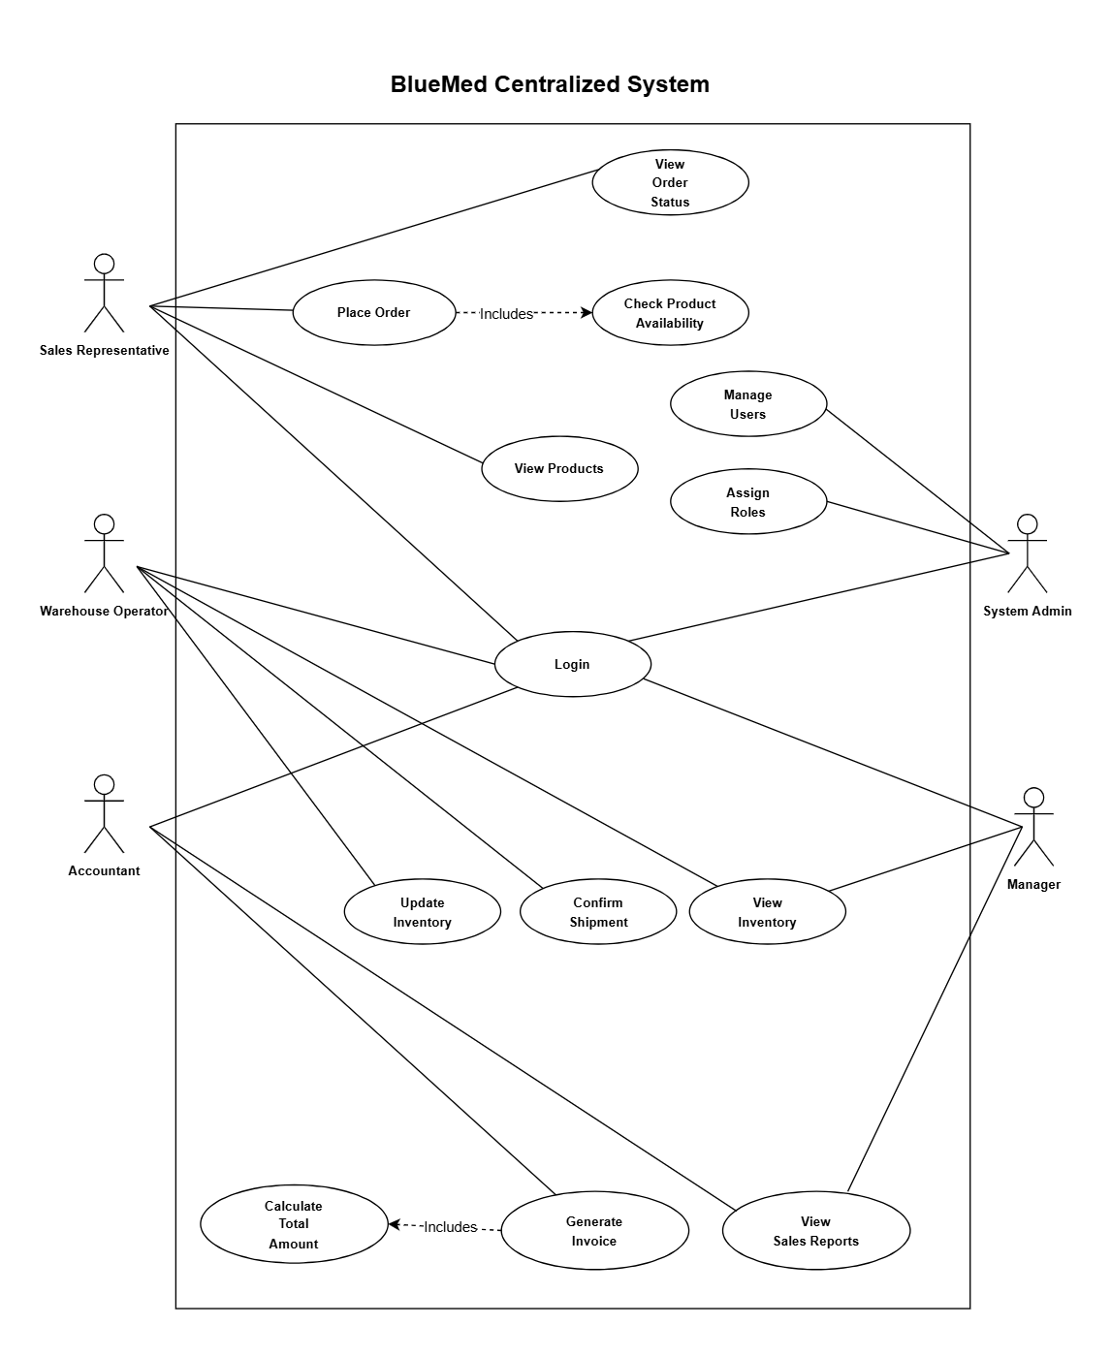

Entity-Relationship Diagram (ERD) Introduction
The ERD defines the structural foundation , mapping how critical data points such as medical products, warehouse stock levels, and hospital contracts relate to one another.
